
Kelly S. Rowe
Sheriff

Joe Gilliam
Chief Deputy LE

Mike Reed
Chief Deputy Detention

LUBBOCK COUNTY SHERIFF’S OFFICE
P. O. Box 10536
Lubbock, TX 79408
Phone: (806) 775-1469
Fax: (806) 775-1491

Lubbock County Sheriff’s Office
Academy Address

801 Main Street
Lubbock, Texas 79401

GPS – 801 Main Street
It is located at the South side of intersection Main St. & Ave. G Across the street for Parking Lot C
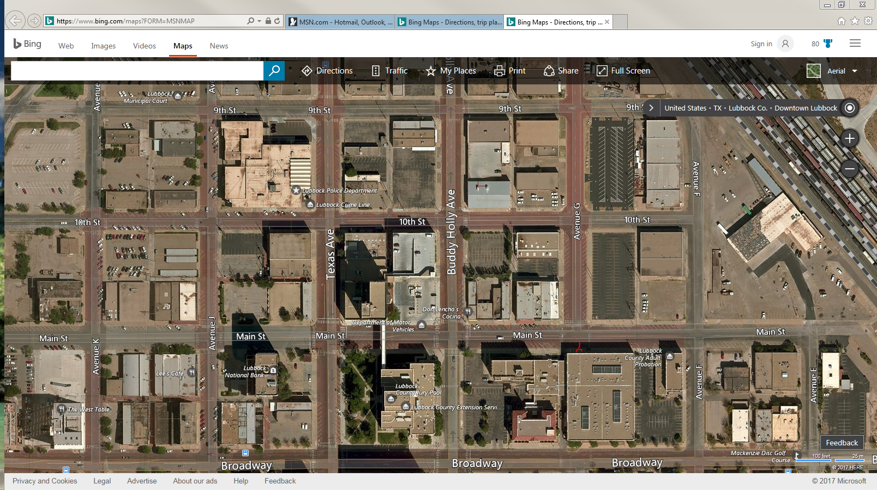
The BLUE ARROW indicates the entrance to the Academy.
The BLUE STAR indicates Parking Lot C.
The ORANGE STAR indicates Parking Lot L.
Students will be allowed to park in Parking Lots C & L.

