Additional Instructions for Using Zoom For Impaneling
This is intended to provide specific instructions for navigating aspects of Zoom needed for impaneling. For more information about Zoom, use the following links:
- Joining a Meeting
- Participant Controls During a Meeting
- Changing Video Settings to view up to 49 participants on one screen –
This will allow you to see more of the panel at one time.
  - Open Video Settings by clicking the small up arrow next to the video camera icon
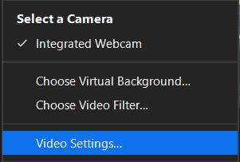
This will pull up a menu, where you should select “Video Settings…”
If you scroll to the bottom of the video settings, you should see an option that says: Display up to 49 participants per screen in Gallery view”. Make sure that item is checked.
- Accessing and Leaving Breakout Rooms
You will be designated a Co-Host by the meeting Host. This will allow you to move in and out of any breakout rooms. There will be a room called “Bench Conference” where you will be able to speak with individual jurors privately.

To enter a Bench Conference, click on the Breakout Rooms Icon at the bottom of your screen:

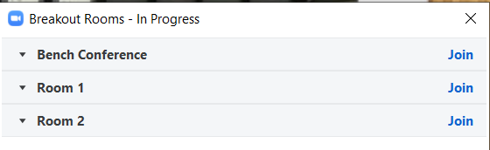
This will pull up the Breakout Rooms dialog Box. Just click on the blue “Join” Button next to the Bench Conference room.

To leave the breakout room, click on the “Leave Room” button at the bottom of the screen. You will be returned to the main room. DO NOT SELECT “LEAVE MEETING”.

