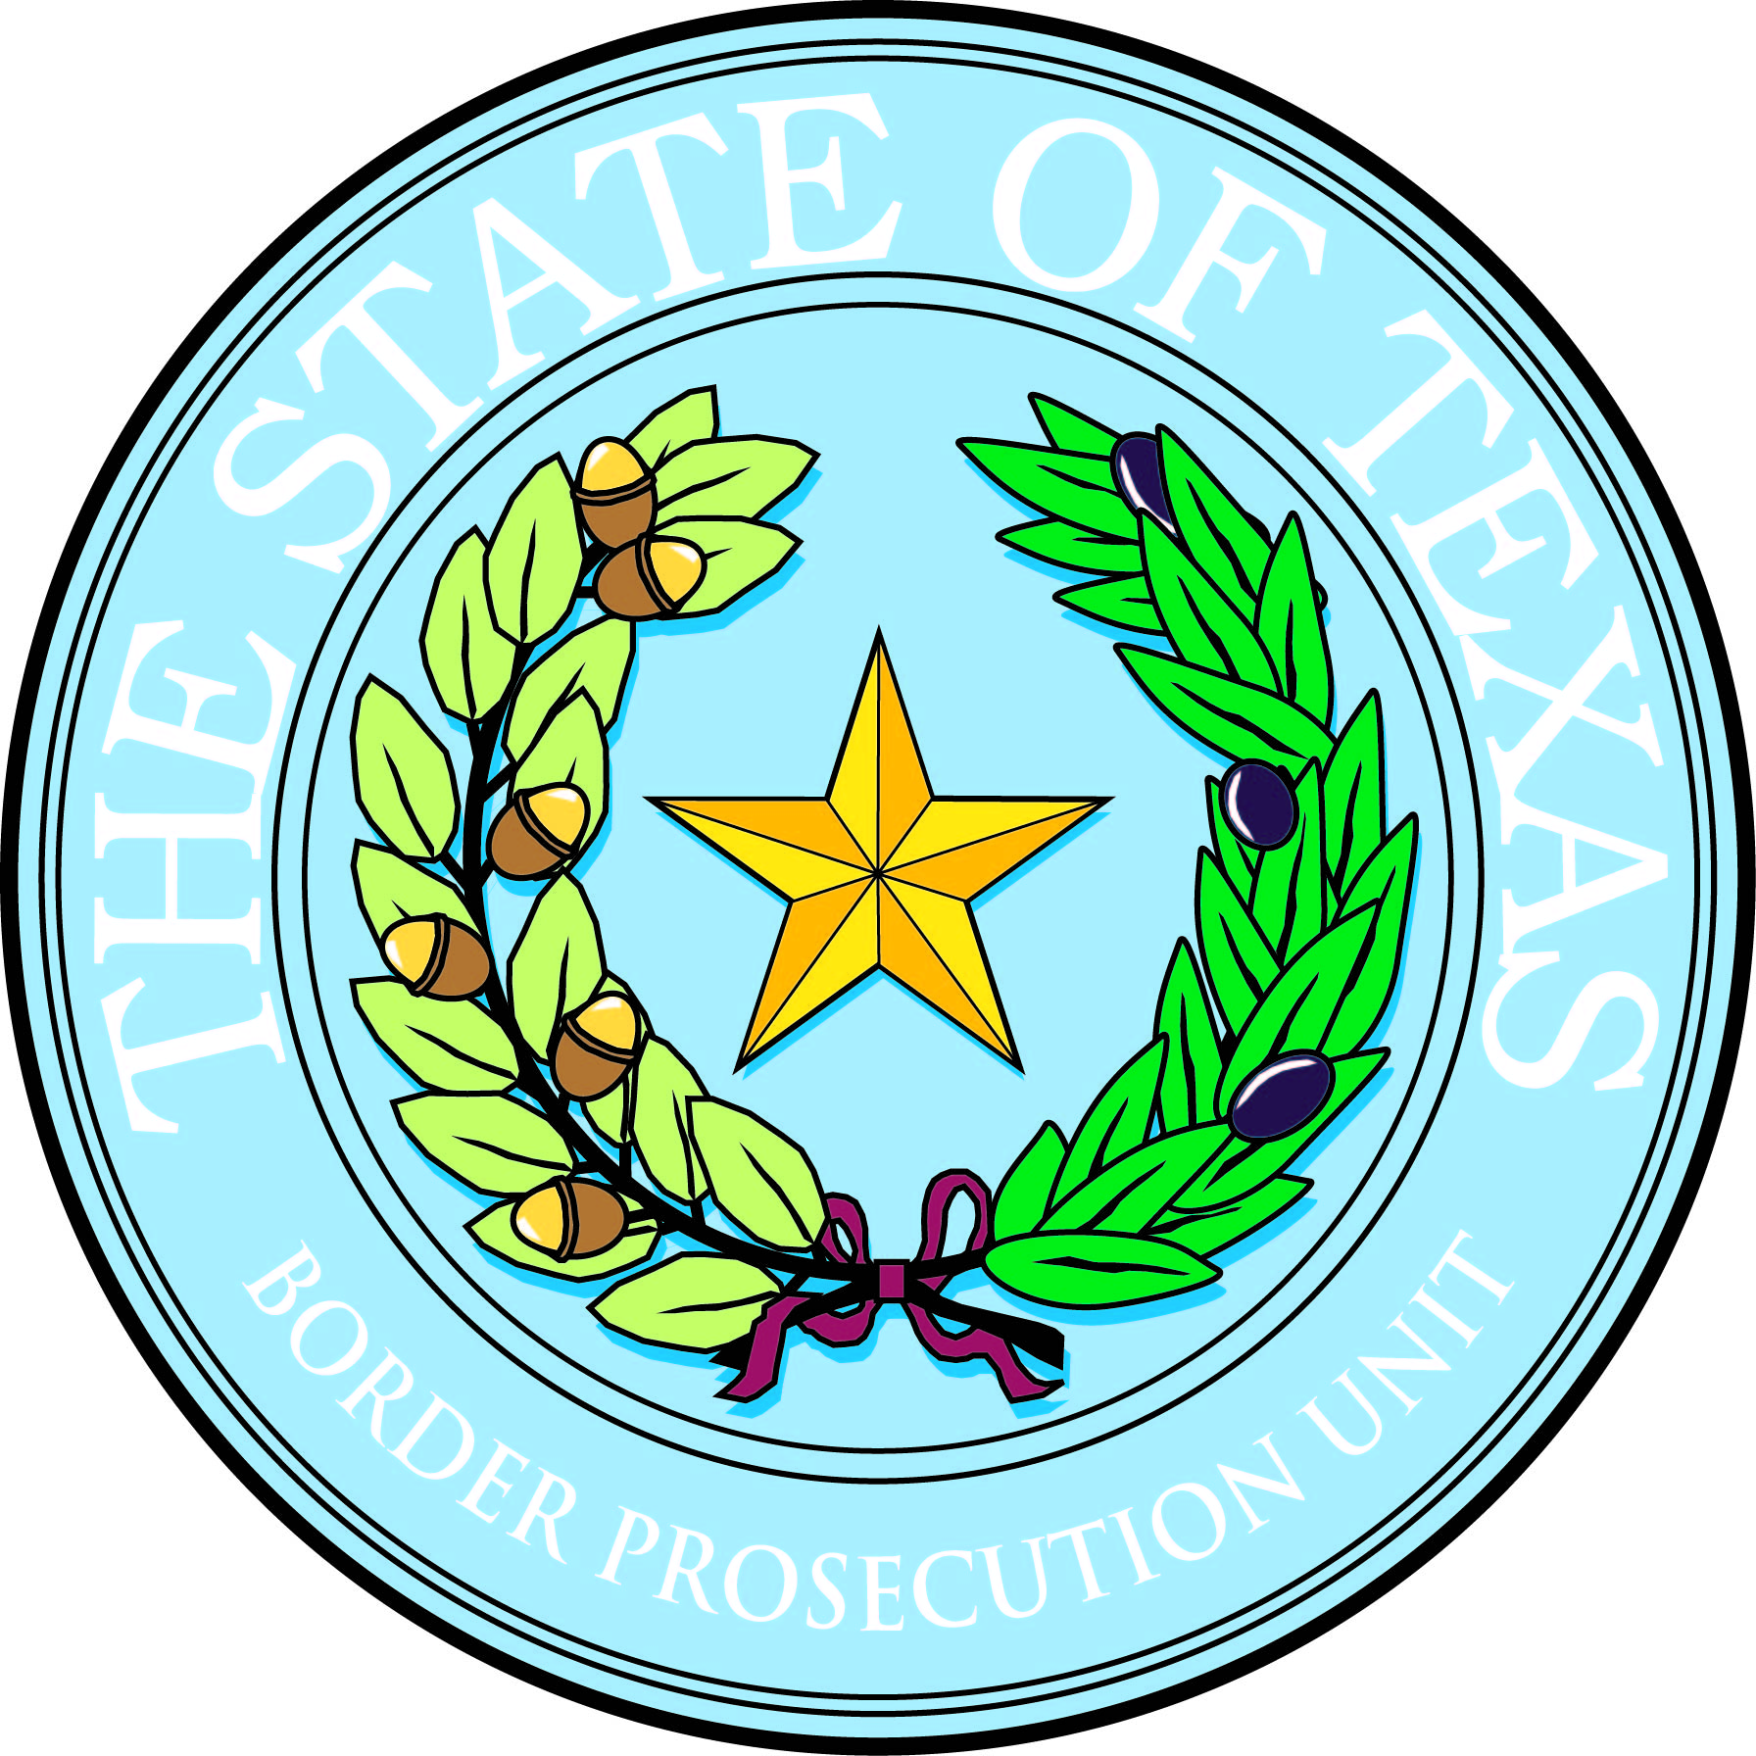
Billy Hicks, Jr.
Border Prosecution Unit Project Director
b.hicks@epcounty.com

500 E. San Antonio, Suite 203
El Paso, Texas 79901
Tel: (915) 546-2059
Fax: (915) 533-5520

BORDER PROSECUTION UNIT
2023 Annual Conference
Atascosa, Bee, Brewster, Brooks, Cameron, Crockett, Culberson, Dimmit, Duval, Edwards, El Paso, Frio, Hidalgo, Hudspeth, Jeff Davis, Jim Wells, Jim Hogg, Karnes, Kenedy, Kinney, Kleberg,
La Salle, Live Oak, Loving, McMullen, Maverick, Medina, Pecos, Presidio, Reagan, Real, Reeves, Starr, Sutton, Terrell, Upton, Uvalde, Val Verde, Ward, Webb, Willacy, Wilson, Zapata, Zavala.
Inn on Barons Creek
Fredericksburg, TX | June 26–29, 2023
Atascosa, Bee, Brewster, Brooks, Cameron, Crockett, Culberson, Dimmit, Duval, Edwards, El Paso, Frio, Hidalgo, Hudspeth, Jeff Davis, Jim Wells, Jim Hogg, Karnes, Kenedy, Kinney, Kleberg,
La Salle, Live Oak, Loving, McMullen, Maverick, Medina, Pecos, Presidio, Reagan, Real, Reeves, Starr, Sutton, Terrell, Upton, Uvalde, Val Verde, Ward, Webb, Willacy, Wilson, Zapata, Zavala.
________________________________________________________________
15.5 total hours, including 1 hour of ethics
MCLE Course #174195723
15 hours TCOLE #3150

Monday, June 26

1:00 p.m. Welcome & Introduction
Tom Krampitz, General Counsel, Border Prosecution Unit

1:15 p.m. Update on the 88th Texas Legislative Session
Rob Kepple, TDCAA Executive Director

2:30 p.m. Break

2:45p.m. Legislative Funding for BPU
Tom Krampitz, General Counsel, Border Prosecution Unit

3:30 p.m. Break

3:45 p.m. Regional Breakout Meetings: Budget Priorities and Regional Requests
Tom Krampitz, General Counsel, Border Prosecution Unit

5:00 p.m. Adjourn

Tuesday, June 27

9:00 a.m. Getting to Know Our Federal Partners
Jaime Esparza, United States Attorney for the Western District of Texas, and
Alamdar Hamdani, United States Attorney for the Southern District of Texas

10:00 a.m. Break

10:15 a.m. Operational Strategies for Investigating Fentanyl Overdoses
F. Tyson Hodges, Asst. Special Agent in Charge, Drug Enforcement
Administration, Austin District Office

11:45 Lunch (on your own)

1:15 p.m. Legalization of Marijuana: Considerations in Prosecution
Kenny Lam, Border Prosecutor, 81st Judicial District Attorney’s
Office

2:15 p.m. Break

2:30 p.m. An Overview of the DPS Criminal Investigations Division Investigative Support Section
Major David Dixon, Texas Department of Public Safety, Austin

3:30 p.m. Break

3:45 p.m. Smuggling, A View From the Side of the Road
Nelson Barnes, BPU Project Director OLS

5:00 p.m. Adjourn

Wednesday, June 28

9:00 a.m. Strategies for Prosecution of Human Smuggling Cases: A Roundtable Discussion
Moderator, Audrey Louis, 81st Judicial District Attorney

10:00 a.m. Break

10:15 a.m. Voir Dire on a Human Smuggling Case
Terese Buess, Retired Asst. District Attorney, Fort Bend County

11:45 p.m. Lunch (on your own)

1:15 p.m. Motions to Suppress
Lance Long, Asst. Criminal District Attorney, Smith County

2:15 p.m. Break

2:30 p.m. Search Warrant Caselaw Update and Common Errors to Avoid in Reviewing Search Warrants
Mark Edwards, 32nd Judicial District Attorney (retired), and
Samantha DiMaio, BPU TAG Attorney (retired), Bexar County

3:30 p.m. Break

3:45 p.m. Search Warrant Caselaw Update and Common Errors to Avoid in Reviewing Search Warrants (cont’d)

5:00 p.m. Adjourn

Thursday, June 29

9:00 a.m. Michael Morton Act, From Investigation to Punishment
Lance Long, Asst. Criminal District Attorney, Smith County

10:00 a.m. Break

10:15 a.m. Significant Decisions of the U.S. Supreme Court and Texas Court of Criminal Appeals
Hon. David Newell and Hon. Bert Richardson, Court of Criminal Appeals

Noon Adjourn

