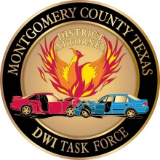
Montgomery County District Attorney’s Office
Vehicle Consent to Search and Download Data Form

I, ________________________________________________, hereby grant my consent to the Montgomery County District Attorney’s Office and any designed law enforcement agency acting on their behalf to search the following:
Current Vehicle Location:
VIN:
Color: | Year: | Make:
Model: | License Plate:
I understand that the search includes the entire vehicle, including containers and contents therein and any data recording device installed in the vehicle. I also understand that any and all information that can be retrieved from any data recording device installed in the vehicle will be downloaded and retained for evidence.
I give consent for any data recording device to be removed, if necessary, from the vehicle for as long as necessary to download and retrieve data from the device.
I understand that the any information obtained from the device will be processed in relation to the following motor vehicle crash:
Location:
Date: | Approximate Time:
I understand that I have the right to refuse consent to the search described above and to refuse to sign this form. I further state that no promises, threats, force, or physical or mental coercion of any king have been used against me to obtain my consent to the search described in this form.
_____________________________________ _____________________________________
Signature of Person Giving Consent Date
_____________________________________ _____________________________________
Printed Name of Person Giving Consent Person’s Relationship to Vehicle

