CAUSE NO. [cause]

STATE OF TEXAS § IN COUNTY CRIMINAL COURT
§
V. § AT LAW NO. [court],
§
[defendant] § HARRIS COUNTY, TEXAS

───────────────────────────────────────────────
Motion to Modify Article 17.151 Deadline
───────────────────────────────────────────────
Pursuant to the First Emergency Order Regarding the COVID-19 State of Disaster jointly issued by the Texas Supreme Court and the Texas Court of Criminal Appeals on March 13, 2020 (“First Emergency Order”), the State of Texas moves to modify the deadline requiring the State to be ready for trial within 90 days, as required by Article 17.151, Section 1(1) of the Code of Criminal Procedure (“Article 17.151”). In support of the instant motion, the State makes the following showing to the Court:
A. Relevant Facts
Pursuant to Texas Rule of Evidence 201(b) and (d), the State moves the Court to take judicial notice of the following facts:
- On March 13, 2020, Texas Governor Greg Abbott declared a state of disaster in all 254 counties in the State of Texas in response to the imminent threat of the COVID-19 pandemic.
- Also on March 13, 2020, the Texas Supreme Court and Texas Court of Criminal Appeals issued a joint order providing, in pertinent part:
Subject only to constitutional limitations, all courts in Texas may in any case, civil or criminal—and must to avoid risk to court staff, parties, attorneys, jurors, and the public—without a participant’s consent . . . [m]odify or suspend any and all deadlines and procedures, whether prescribed by statute, rule, or order, for a stated period ending no later than 30 days after the Governor’s state of disaster has been lifted . . . .
First Emergency Order, at 1 (emphasis added).
- On March 19, 2020, the Texas Supreme Court and Texas Court of Criminal Appeals issued a joint order providing, in pertinent part:
Courts must not conduct non-essential proceedings in person contrary to local, state, or national directives, whichever is most restrictive, regarding maximum group size.
Third Emergency Order, at 1 (emphasis added).
- Also on March 19, 2020, Governor Abbott issued an executive order relating to COVID-19 preparedness and mitigation that explicitly calls upon “every person in Texas” to “avoid social gatherings in groups of more than 10 people.” Tex. Gov. Exec. Order No. GA–08 (Mar. 19, 2020). That order remains in effect.
- Should the proceedings of the Harris County grand juries continue while Governor Abbott’s executive order remains effective, this almost certainly will entail violation of that order. See Tex. Code Crim. Proc. art. 20.21 (providing that, at minimum, nine members of the grand jury must be present when an indictment is presented by the attorney representing the State).
- Presentation of cases to the Harris County grand juries has been significantly curtailed as a result of the COVID-19 pandemic in consideration of the health and safety of the grand jurors and persons interacting with them. See Attachment A (Aff. of Bureau Chief Jim Leitner).
- On [date], the Defendant’s detention in jail pending trial of a felony accusation against the Defendant commenced.
B. Authority to Extend Deadlines
The Legislature has accorded the Texas Supreme Court and the Texas Court of Criminal Appeals the authority to “modify or suspend procedures for the conduct of any court proceedings affected by a disaster during the pendency of a disaster declared by the governor.” Tex. Gov’t Code § 22.0035(b).
In 2009, when Section 22.0035 was enacted, the Chair of the House Judiciary and Civil Jurisprudence Committee explained the legislative intent behind the provision:
What this does is [H.B.] 1861 establishes that the Supreme Court and the Texas Court of Criminal Appeals have full rulemaking power to extend a statutory deadline for not more than 30 days in a county in which a disaster has occurred. If you remember, like they had in Louisiana and some of the Gulf Coast states as well, is I thought we were very prepared in Texas but it’s in the situation you want to give them that flexibility for any cases that are pending at that time. And it’s basically a practical bill and lays out some pretty good practical sense.
House Judiciary & Civil Juris. Comm., H.B. 1861, Apr. 6, 2009 (archived at http://tlchouse.granicus.com/MediaPlayer.php?view_id=25&clip_id=3728 at 1:26:10) (last visited Mar. 19, 2020).
C. Release Pursuant to Article 17.151 Is Not a Constitutional Right
In 1977, the Legislature enacted Article 17.151 as part of the Speedy Trial Act, which also gave rise to Article 32A.02, Code of Criminal Procedure. Article 32A.02 was later ruled unconstitutional as an infringement of the separation of powers doctrine. Meshell v. State, 739 S.W.2d 246, 257 (Tex. Crim. App. 1987). By contrast, Article 17.151 was spared the same separation of powers invalidation because it “does not interfere unduly with the prosecutor’s function.” Jones v. State, 803 S.W.2d 712, 716 (Tex. Crim. App. 1991).
In upholding Article 17.151, the Jones Court expressly pointed out that the statute was not premised on a constitutional right to release on bail:
We do not mean to suggest an accused has a constitutional right to have bail set at an amount he can meet, under Article I, §§ 11 or 13 of the Texas Constitution. This Court has never so held, and in fact on numerous occasions has remarked that in setting bail, “[t]he ability of accused to make bond is not alone controlling.”
Id. (quoting Ex parte Cascio, 144 S.W.2d 886 (Tex. Crim. App. 1940)). Instead, the Court summarized the intention of the statute as “guarantee[ing] an accused will not be detained pretrial for an inordinate length on account of a lack of diligence by the State in preparing its case.” Id. at 717.
The State has found no authority from any court following the Jones decision that has ever characterized Article 17.151 as being of constitutional dimension. Accordingly, whatever rights may be found in Article 17.151 are purely statutory; as such, those rights may be abridged by the same Legislature that created them.
D. Emergency Orders Issued Pursuant to Section 22.0035 Do Not Violate Article I, Section 28 of the Texas Constitution
Because Article I, Section 28 of the Texas Constitution provides that “[n]o power of suspending laws in this State shall be exercised except by the Legislature,” Tex. Const. art. I, § 28, it is important, as a threshold matter, to establish that the First Emergency Order and an exercise of authority pursuant to that order—specifically, the modification of Article 17.151’s 90-day deadline—are compatible with this constitutional provision.
Although the First Emergency Order authorizes the “suspen[sion]” of “deadlines and procedures,” the State, through the instant motion, does not seek suspension of Article 17.151 but, rather, a modification of the statute’s 90-day deadline, in deference to the extraordinary circumstances of the present disaster. The words suspension and modification are not synonymous: the Constitution’s purposeful use of the narrow word “suspending” in Article I, Section 28 appears to have been intended to prevent the usurpation of power by the Governor. See generally Practice Commentary, Tex. Const. art. I, § 28 (“Such a provision was written into the fundamental law mainly as direct inhibition upon the executive, the thought being that the people's representatives who are empowered to enact the law should be the only body empowered to suspend those laws.”); Constantin v. Smith, 57 F.2d 227, 237 (E.D. Tex. 1932) (explaining that the provisions of the 1876 Constitution, including Article I, Section 28, were “written into the fundamental law as direct inhibitions upon the executive, by men who had suffered under the imposition of martial law, with its suspension of civil authority, and the ousting of the courts during reconstruction in Texas”).
Unlike the suspension of existing law and imposition of martial law, this is not an instance in which the judiciary is being called upon to suspend a law without legislative permission. Instead, this Court’s modification of Article 17.151’s 90-day deadline would be an extension of the Texas Supreme Court and Texas Court of Criminal Appeals’ authority—extant only under extraordinary circumstances, and pursuant to a law promulgated by the Legislature itself—to administer a legislative grant of authority, viz., to “modify or suspend procedures for the conduct of any court proceeding affected by a disaster during the pendency of a disaster declared by the governor.” Tex. Gov’t Code § 22.0035(b) (emphasis added). As stated in Part A, supra, the First Emergency Order expressly relies on this provision; moreover, the emergency order tracks the language of Section 22.0035(b). Compare id., with First Emergency Order, at 1 (requiring that “all courts in Texas” “[m]odify or suspend any and all deadlines and procedures, whether prescribed by statute, rule, or order,” “to avoid risk to court staff, parties, attorneys, jurors, and the public”). And in further adherence to Section 22.0035(b), the First Emergency Order limits any modification to “a stated period ending no later than 30 days after the Governor’s state of disaster has been lifted.” First Emergency Order, at 1.
The Legislature specifically limited the length of time in which procedural modifications could occur, but it authorized those modifications as expressions of its authority, not a delegation of it. Section 22.0035(b) is an act of the Legislature that permits the Texas Supreme Court to administer the disaster provision, not circumvent legislative authority. See generally Practice Commentary, Tex. Const. art. I, § 28 (2007) (“For example, if an executive agency or a local government should take action in the suspension of a law, independently of any delegation by the Legislature, that action could be nullified under this provision without a consideration of the question of legislative declaration of power.”).
The Legislature has properly utilized its authority without violating Article I, Section 28 of the Texas Constitution in the past, such as when it permitted the Texas Supreme Court and Texas Court of Criminal Appeals to create rules of evidence and procedure for civil and criminal cases. See Tex. Gov’t Code §§ 22.004 (providing the Texas Supreme Court with rulemaking power in the practice and procedure in civil actions), 22.108 (granting the Texas Court of Criminal Appeals rulemaking power to promulgate rules for appellate procedure), 22.109 (authorizing the Texas Court of Criminal Appeals the full rulemaking power in the promulgation of rules of evidence in the trials of criminal cases). It likewise properly utilized its authority when, in 2017, the criminal justice systems in numerous Texas counties were significantly disrupted due to Hurricane Harvey and, because of those disruptions, the Texas Supreme Court and Texas Court of Criminal Appeals issued emergency orders not unlike the present one. See, e.g., Emergency Order Authorizing Modification and Suspension of Court Procedures in Proceedings Affected by Disaster, Misc. Docket No. 17–9091 (Tex. Aug. 28, 2017), Misc. Docket No. 17–010 (Tex. Crim. App. Aug. 28, 2017).
The Court of Criminal Appeals reached a similar conclusion in a challenge to a legislative delegation of authority in Masquelette v. State. In Masquelette, the Court held that, “[s]o long as the statute is sufficiently complete to accomplish the regulation of the particular matters falling within the Legislature’s jurisdiction, the matters of detail that are reasonably necessary for the ultimate application, operation and enforcement of the law may be expressly delegated to the authority charged with the administration of the statute.” 579 S.W.2d 478, 480 (Tex. Crim. App. [panel op.] 1979 (citing Commissioners Court of Lubbock County v. Martin, 471 S.W.2d 100 (Tex. Civ. App.—Amarillo 1971, writ ref’d n.r.e.)). In the instant case, the Legislature permitted the Texas Supreme Court the authority to administer the “Modification or Suspension of Certain Provisions Relating to Court Proceedings Affected by Disaster” through the modification of statutory procedures, and, in turn, the Texas Supreme Court has permitted this Court the authority to modify Article 17.151’s 90-day deadline.
This is further evidenced by the Section 22.0035 language. The Legislature defined the term disaster by statute. See Tex. Gov’t Code § 22.0035(a) (cross-referencing Section 418.004’s definition of disaster). It further required that the Governor declare that a disaster does, in fact, exist, and it limited the duration of a modification or suspension order to “the pendency of [the] disaster.” Id. at § 22.0035(b).
The grant of authority to modify certain provisions for a disaster does not differ from the Texas Supreme Court and the Texas Court of Criminal Appeals’ ability to promulgate rules and procedures. It is also important to note that the Court’s First Emergency Order did not suspend the rules. Rather, it authorized the modification of deadlines for the period in which the COVID-19 state of disaster is pending. See also In re C.M.J., 573 S.W.3d 404, 407–09 (Tex. App.—Houston [1st Dist.] 2019, no pet.) (approving a district court’s delay in a mandatory statutory deadline to finalize a parental-termination order because that delay was supported by a valid exercise of the Texas Supreme Court’s authority under Section 22.0035(b) following the Hurricane Harvey disaster).
In view of the foregoing, the First Emergency Order is not unconstitutional.
E. Article 17.151 Deadline Should Be Extended
Through no fault of the State, and due to the extraordinary circumstances of the damage inflicted on the Harris County criminal justice system by the COVID-19 pandemic, the Defendant either was not indicted or cannot feasibly be indicted within 90 days of the Defendant’s detention for the felony offense alleged in the charging instruments for the above styled and numbered cause.
As noted in the legislative history quoted above, the intention of the Legislature in authorizing the Texas Supreme Court and Texas Court of Criminal Appeals to modify deadlines in deference to disaster-related delays was precisely to give the courts flexibility in extraordinary circumstances like the current disaster.
Moreover, extending the Article 17.151 deadline beyond the 90-day window would not be inconsistent with the statute’s purpose, which was to incentivize the State to ensure its readiness for trial in a timely fashion. Any present inability of the State to meet that deadline cannot be attributed to a lack of diligence on the part of the State to prepare its case for trial. In fact, holding that the Defendant is entitled to release notwithstanding the disaster-created delay would have the effect of substantially abridging the time that the Legislature has accorded to the State to prepare for trial. In essence, Article 17.151 gives the State 90 days to get ready for trial, and Section 22.035 gives the courts a limited, but effective, mechanism to vindicate the State’s statutory trial preparation period in the aftermath of a disaster.
The First Emergency Order does not exceed the scope of authority granted to the Texas Supreme Court and the Texas Court of Criminal Appeals by the Legislature under Section 22.0035, and the modification by this Court of the automatic-release deadline in Article 17.151 pursuant to that emergency order does not exceed the scope of authority pursuant to the order.
Accordingly, the State moves for an order modifying the statutory deadline under Article 17.151 to obtain the indictment of the Defendant due to delay in grand jury proceedings caused by the COVID-19 state of disaster.

Respectfully submitted,

/s/ [prosecutor]
[PROSECUTOR]
Assistant District Attorney
Harris County, Texas

500 Jefferson Street, 6th Floor
Houston, Texas 77002

Attachment A

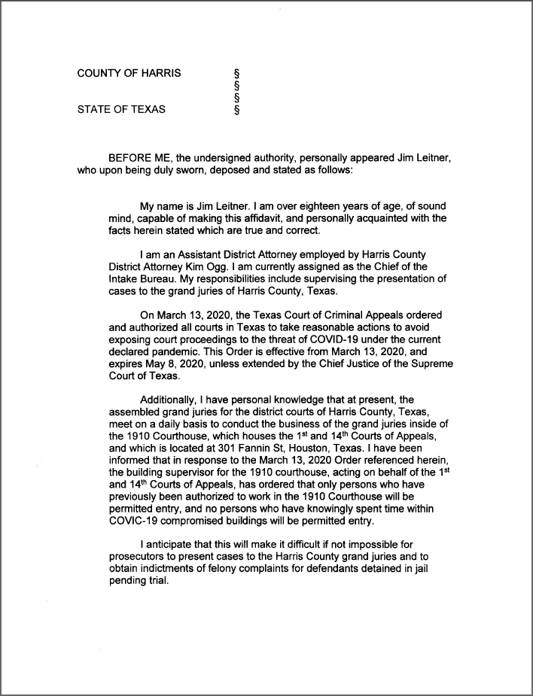

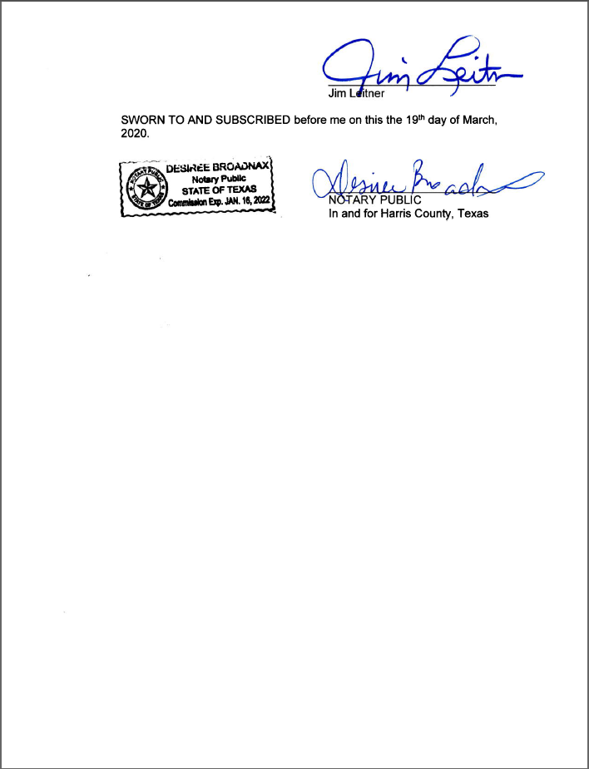

CERTIFICATE OF SERVICE
I hereby certify that service has been accomplished by delivering a true and correct copy of this document to the defendant on [date], the date of filing with the clerk of this Court.

/s/ [prosecutor]
[PROSECUTOR]
Assistant District Attorney
Harris County, Texas

500 Jefferson Street, 6th Floor
Houston, Texas 77002

CAUSE NO. [cause]

STATE OF TEXAS § IN COUNTY CRIMINAL COURT
§
V. § AT LAW NO. [court],
§
[defendant] § HARRIS COUNTY, TEXAS

───────────────────────────────────────────────
ORDER
───────────────────────────────────────────────
The State of Texas’s Motion to Modify Article 17.151 Deadline is hereby GRANTED.
Pursuant to the authority of the First Emergency Order Regarding the COVID-19 State of Disaster jointly issued by the Texas Supreme Court and the Texas Court of Criminal Appeals on March 13, 2020 (“First Emergency Order”), this Court hereby modifies the statutory 90-day deadline set forth in Article 17.151 of the Texas Code of Criminal Procedure (“Article 17.151”) to extend to May 8, 2020, the expiration date of the First Emergency Order, and further finds that the State is not in violation of Article 17.151, Section 1(1) in the above captioned and numbered cause and is ready for trial.
Signed this [date].

[judge]
PRESIDING JUDGE
[court]
Harris County, Texas

